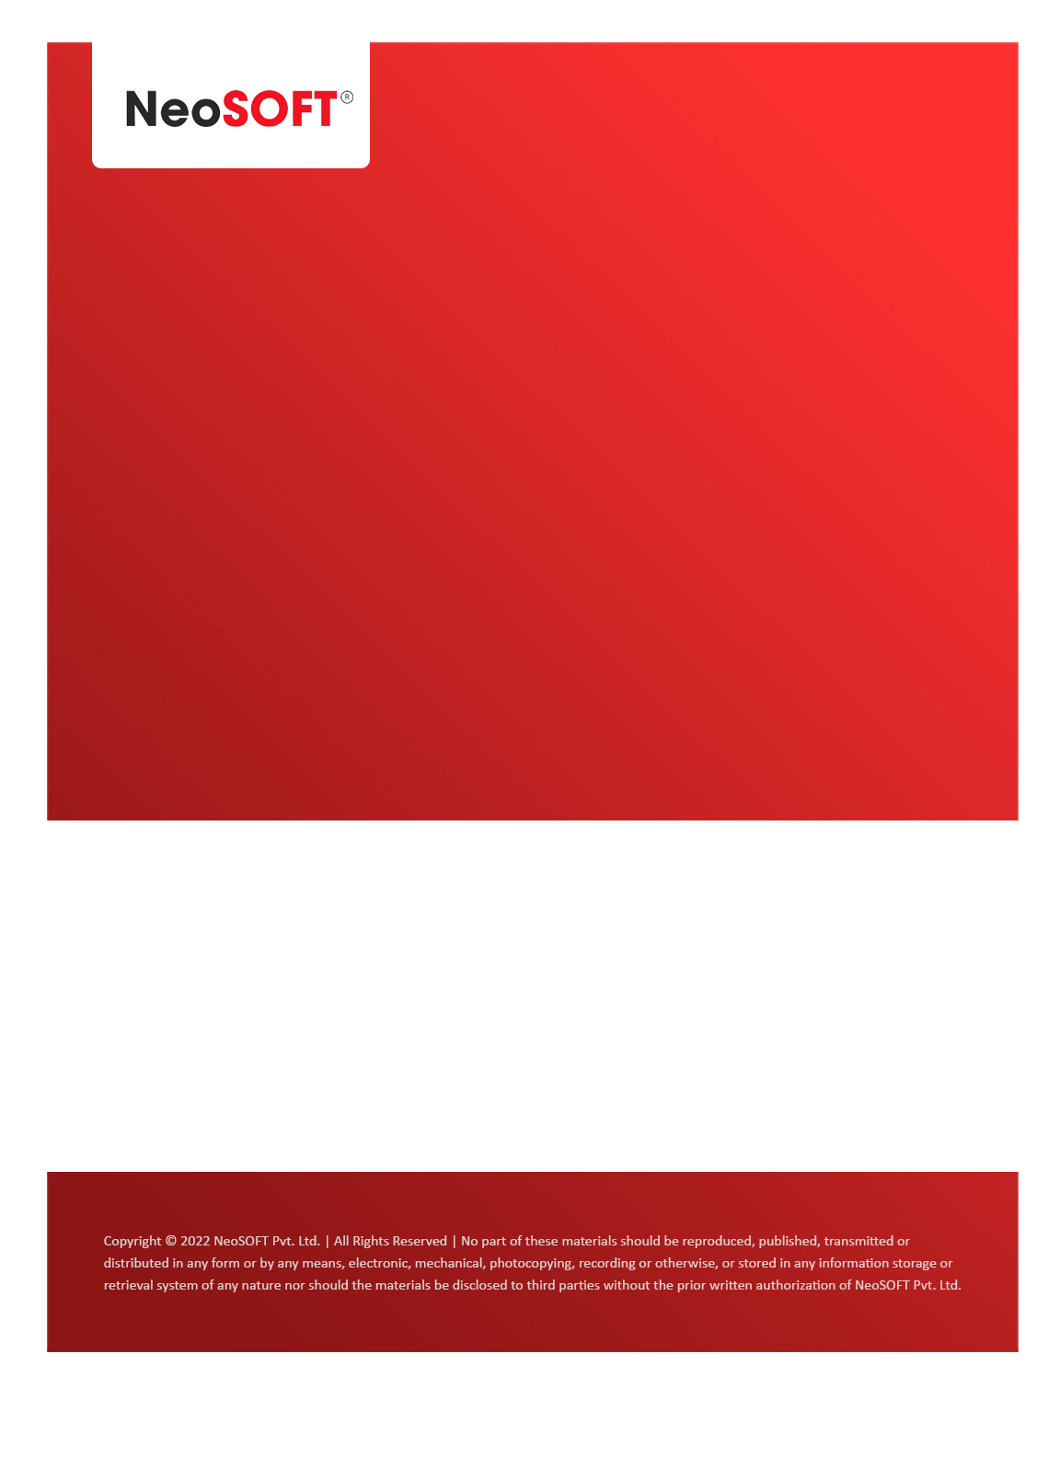`

**Eltizam MOM – Wireframes review and Questions**

Eltizam

Client Name

NeoSOFT is a SEI-CMMI Level-5 Global IT Consulting & Software Solutions Provider

**May 09,** 2023

|  |  |
| --- | --- |
| **Meeting Date, Time, and Attendee Details** | |
| **Date** | 9th May 2023 |
| **Venue** | MS Teams |
| **Time** | 02.00 PM – 03.00 PM IST |
| **Meeting Type** | Wireframes review, Project status |
| **Internal Attendees** | * YallaReddy * Akshata Shinde |
| **Client Attendees** | * Karuna Pawar |
| **Presented By** | * Karuna Pawar * Akshata Shinde |
| **MOM Prepared By** | * YallaReddy |

|  |  |
| --- | --- |
| **Details of Meeting** | |
| **Sr. No.** | **Description** |
| 1 | Discussed completed wireframes for Evaluation process module and reviewed them with Karuna. |
| 2 | Got very few changes from review session and we are working on them. Will be done those minor changes and present to Vinod & team on Thursday’s call. |
| 3 | Requested Karuna to get information on   * Evaluation Assessment form * Invoice receipt * Payment receipt details. |
| 4 |  |
| 5 |  |

|  |  |  |  |  |  |
| --- | --- | --- | --- | --- | --- |
| **Actionable** | | | | | |
| **Sr. No.** | **Action Item** | **Assigned to** | **Assigned Date** | **Expected Completion Date** | **Status** |
| 1 |  |  |  |  |  |
|  |  |  |  |  |  |
|  |  |  |  |  |  |